HEART PULSE MONITORING AND NOTIFICATION SYSTEM USING ARDUINO

Hari Kiran Pendurthi ¹
Department Of CSE
Koneru Lakshmaiah Educational Foundation
Vaddeswaram, India
170031577@kluniversity.in

Siva Sai Kanneganti ¹
Department Of CSE
Koneru Lakshmaiah Educational Foundation
Vaddeswaram, India
170030556@kluniversity.in
Hemanth Sai Gokarakonda ¹
Department Of CSE
Koneru Lakshmaiah Educational Foundation
Vaddeswaram, India
170030384@kluniversity.in

Dr. S. Kavitha ¹
Department Of CSE
Koneru Lakshmaiah Educational Foundation
Vaddeswaram, India
kavithabtech05@kluniversity.in
Jaswanth Godavarthi ¹
Department Of CSE
Koneru Lakshmaiah Educational Foundation
Vaddeswaram, India
170030477@kluniversity.in

Abstract — As we all know one among the fatal problems which cause the death of humans is respiratory problems. On the off chance that checking our wellbeing consistently, at that point we can identify various sicknesses by recognizing them well in advance. Many individuals have lost their lives to coronary syndromes. So we have developed a system using Internet of Things to assist individuals and help them get immediate treatment. In this system we use a pulse sensor which when a finger is placed on it calculates the heartbeat of the person. In this system there are two segments the hardware which is used to calculate heartbeat and the other is to continuously monitor heartbeat data which is collected in the previous step. This sensor is then interfaced to an Arduino UNO microcontroller that permits checking of the heartbeat value and communicating them to the internet by using Bolt Wi-Fi module. The data is sent an AWS server via bolt cloud which continuously monitors the heartbeat for any abnormalities. The client can set a limit whenever the client’s heartbeat exceeds the threshold limit then by using online API services like Twilio we send SMS to the doctor/client stating the patient’s current heartbeat. In this way we are providing a solution to monitor the heartbeat of a patient remotely and give an automated response according to the heartbeat.
Keywords — Heartbeat, Internet of Things (IOT), Cloud Computing (CC), Arduino UNO, Bolt Wi-Fi module, AWS server, API’s.

Introduction

This covid-19 pandemic has caused many problems to everyone and especially the most affected ones are the patients. Patients whose heart pulse needs to be monitored regularly by the concerned doctors are affected by this Covid-19 outbreak. There has been a communication gap formed between these patients their concerned doctors/caretakers. Due to the implementation of lockdown all over the world the situation got worse for the patients. [1] This is where our idea flourished to help those section of patients whose heart pulse needs to be monitored regularly. [6] With the help of the knowledge, we gained from the concepts of IOT and its applications in medical field, we have researched and studied many research papers related to our problem statement. After reviewing many papers, finally we have chosen one paper, as our base paper and started working on the idea. Our project “Heart Pulse Detection and Notification System using Arduino” mainly focuses on the communication gap between the patients and their doctors. The main aim of our project is to establish a communication bridge between the patients and the concerned caretakers/Doctors. [5] We have used reliable components such as Arduino Uno, which is the brains of the system, heart pulse sensor, which detects the heart pulse of the body, and BOLT Wi-Fi module for establishing a connection to send data through internet.
We have used the most reliable VPS service provider which is AWS VPS to run the program(code) required to detect the abnormality present in the heart pulse. For the notification module, we have used TWILIO as our online API service which sends data to the concerned doctor whenever there is an abnormality present in the patient’s heart pulse.
We have implemented the following technologies in out project:
- IOT – IOT stands for Internet of Things. It describes the network of interrelated computing devices that are embedded with sensors, actuators, and software for connecting and exchanging data with other devices in a network via internet.[2] The applications of IOT are divided into 4 types they are of 4 types they are consumer, commercial, industrial, infrastructure. In the consumer market IOT is mainly used with the products pertaining to home automation or smart home systems. IOT can also be applied to healthcare systems this type is known as H-IOT. In our project we have used the H-IOT concept to create a healthcare system which monitors and notifies the doctors about the patient’s heartbeat whenever there is an abnormality. But there are several privacy and security concerns regarding growth of IOT.

- H-IOT – H-IOT stands for healthcare IOT. This is undoubtedly transforming healthcare industry by delivering healthcare IOT solutions.[10] These implementation benefits patients, hospitals, companies.

- IOT for Patients - IOT devices in the form of fitness bands, smart bands give us various data about the patients. These features can be turned on and off according to the requirement of the user. IOT has changed people’s life’s especially elderly patients by monitoring various aspects of the patients continuously.
- IOT for Hospitals –[9] Apart from checking patients health details continuously there are many more advantages of IOT in hospitals. The IOT devices are very useful for tacking medical equipment like wheelchairs, oxygen pumps, and monitoring equipment. Hygiene is also important with the help of IOT devices spread of infectious diseases. IOT can also be used in asset management like environment monitoring, pharmacy inventory control, humidity, and temperature control, etc.
- IOT for Insurance Company’s – There are many opportunities for health insurers with IOT connected intelligent devices. Insurance companies can use the data which is captured through health monitoring devices for underwriting and claims operations.
This project Heartrate monitoring and notification system using Arduino con be useful in IOT for Patients and for Hospitals for monitoring patient’s heartbeat always.
- CLOUD COMPUTING – Cloud Computing refers to providing on demand availability of Computing resources epically data storage and computing power without any direct management by user.[3] This term is used to define datacentres available to many users over the internet. The clouds may be limited to only one organization or to multiple organizations. The cloud providers generally use Pay as you go scheme.[4] We have selected Aws as our cloud because it has a variety of features and follows a pay as you go scheme the cost of using the cloud is limited and with the limited cost we also get a plethora of features to be used in the project which is deployed in AWS server.

- USAGE OF API’S – API stands for Application Programming Interface. This allows to applications to communicate with each other. One of the main requirements of this project to send SMS whenever there is an abnormality so in this case, we use a SMS API service called Twilio. Whenever there is an abnormality detected in the AWS server with the help of a program, we can access Twilio and send SMS about the status of the patient.

Components required

As one of the aims of this project is to provide the implementation at low cost we tried to complete the project using minimal but rather very much effective components. The components which we used are:
- Arduino UNO Board
- Pulse Sensor
- Bolt IOT Wi-Fi Module
- Jumper Wires (M-M,M-F)

- Arduino Uno Board:
Arduino Uno Board is an open-source microcontroller board based on ATmega328P microcontroller which is developed by Arduino. The Arduino Uno board (Fig.2.1) contains a set of pins which are used for input/output purposes. There are 14 digital Input/Output pins and 6 analog Input/Output pins. This board can be programmed by using Arduino IDE by connecting the Arduino to a laptop by using a Type B USB cable or an external power source.

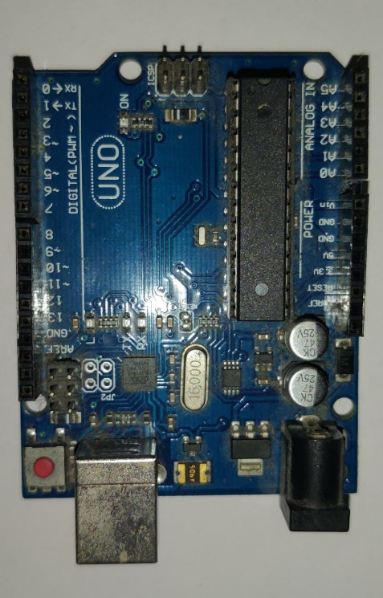
Fig.2.1: Arduino UNO

- Pulse Sensor:
Pulse Sensor(Fig.2.2) is a plug and play device which is designed to work with Arduino for calculating the heartrate of a patient.[11] There are two surfaces and three pins to the sensor one side contains the LED and ambient light sensor on the other surface we have a circuit board containing noise cancellation and amplification. The three pins are ground, VCC(power supply), signal. When we place the sensor on our fingertip the sensor detects the vein which is present in the finger and whenever there is a blood flow change in the veins, we can calculate the heartbeat as well.

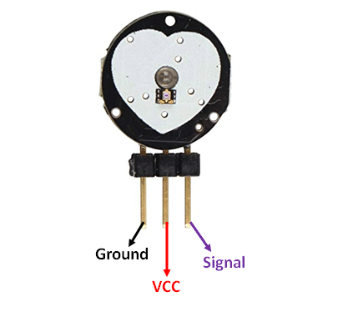
Fig.2.2: Pulse Sensor

- Bolt IOT Wi-Fi Module:
This Wi-Fi module acts as an interface to connect the hardware components to the cloud. This bolt Wi-Fi module(Fig.2.3) is secure and fast. Here there are a few I/O pins which can used according to the user’s requirements. There are two lights present which indicate the working of the module. Green light indicates that the module is connected to cloud and orange light indicates that the Wi-Fi is on.

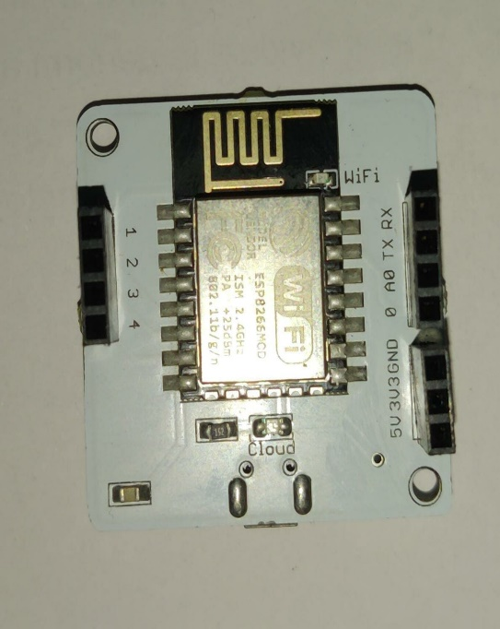
Fig.2.3: BOLT Wi-Fi Module

- Jumper Wires (M-M,M-F):
Jumper wire is just a simple wire that contains connector pins at the extreme ends of the wire which can be used to connect two components into a single working circuit. These can be used without soldering and can be easily interchangable according to the users requirement.In this model we have used M-M (Male to Male) and M-F (Male to Female) variations because it is best suitable for this project.

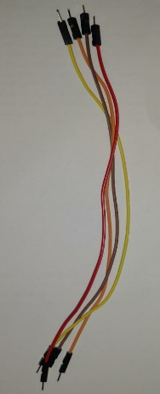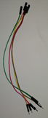
Fig.2.4: Jumper Wires (M-M,M-F)

PROPOSED MODEL

Here are the block diagrams and process flow diagram related to the proposed model of the system.

- Block diagram:

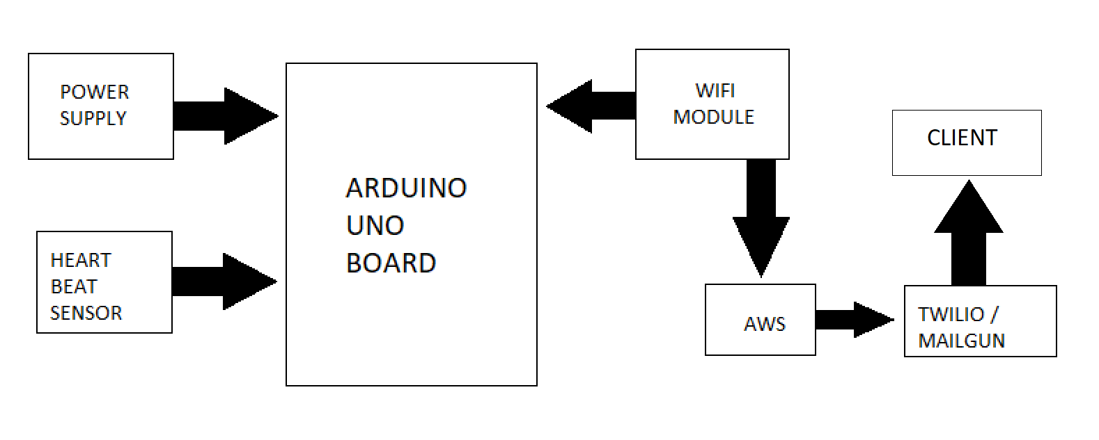
Fig.3.1 Block diagram of this project

- Flow diagram:
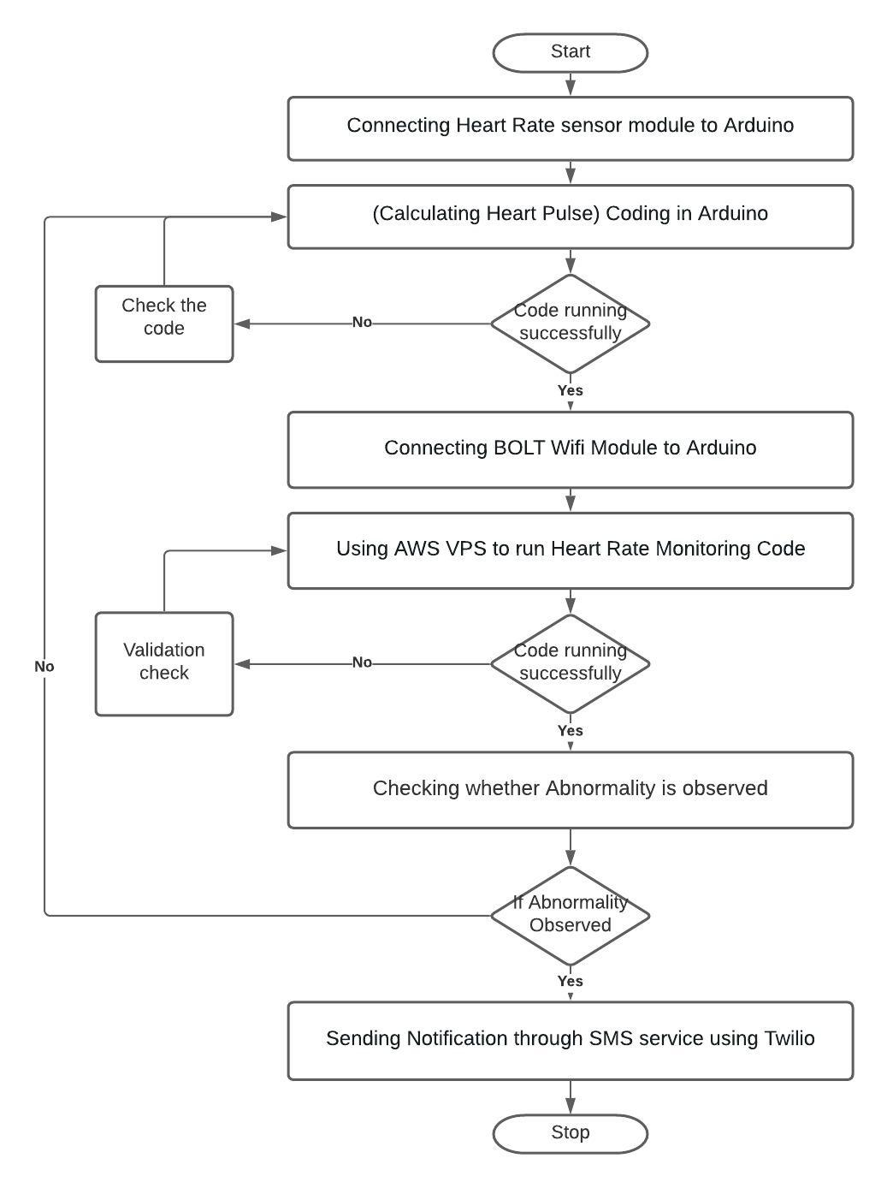
Fig.3.2 Flow chart of this project representing the step-by-step procedure

- Hardware setup:

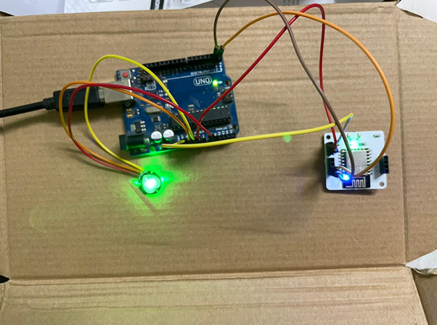

Fig.3.3 Entire hardware setup of this project

Step-1: Connecting the Heart Rate sensor module to Arduino
Arduino Uno Board is an open-source microcontroller board based on ATmega328P microcontroller which is developed by Arduino. The Arduino Uno board (Fig.2.1) contains a set of pins which are used for input/output purposes. There are 14 digital Input/Output pins and 6 analog Input/Output pins. This board can be programmed by using Arduino IDE by connecting the Arduino to a laptop by using a Type B USB cable or an external power source.

In detail explanation about the working of the heart rate sensor:
The heart rate system contains a diode and a photodiode. Whenever we place our finger on the sensor, there will be a disturbance caused by the flow of the light emitted by the diode.
This disturbance is caused by the flow of blood in that finger. The blood in the finger absorbs some of the light emitted by a diode and the remaining reflected light rays are then captured by the detector(photodiode). The detector records the reflected rays which are caused by the disturbance created in the light flow by the flow of blood in the finger. The detector shows the output in the form of a DC signal which is related to the blood volume and the flow of blood in the finger. This is how a heart rate sensor detects the heart pulse of a body.

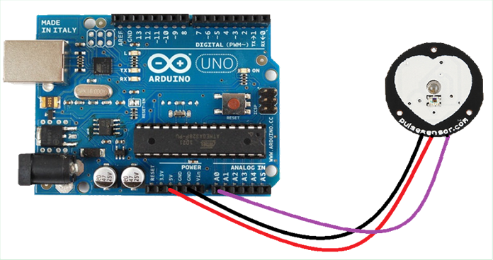
Fig.3.4 Arduino Uno connected to the Pulse Sensor

Step-2: Coding in Arduino (Calculating Heart Pulse)
After successfully connecting the heart rate sensor to the Arduino, we have written a code in the Arduino console for the calculation of heart pulse. We have worked on it and could successfully run the code in the console. Only if the code runs successfully, we need to go to the next step otherwise we need to recheck our written code in the console. The results are shown in the output console.

Step-3: Connecting BOLT Wi-Fi Module to Arduino
After making sure that the code in the console is running successfully and the results are accurately visible in the console present in the system, we now must connect the Wi-Fi module to the Arduino. Since the main aim of our project is to make everything automated, we need a BOLT Wi-Fi module to make a connection with the internet. The BOLT Wi-Fi module is connected to Arduino and a connection between the system and the internet is established. Now we can proceed to the next step where the detected heart pulse data is sent to a virtual private server to check the abnormality present in the data.

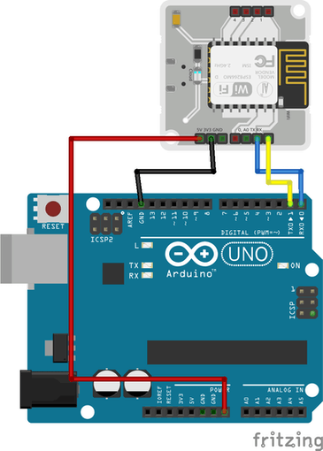

Fig.3.5 Arduino UNO connected to BOLT Wi-Fi Module

Step-4: Using AWS VPS to run Heart Rate Monitoring Code
Now we need an online virtual private server to run the abnormality checking process. We have used AWS based VPS in this step to gather the data acquired from the Arduino UNO and to check the abnormality of the pulse. AWS VPS is user friendly and very reliable. We have created a new Linux server dedicated to that system to calculate the abnormality. Here we need to upload our code to check the abnormality present in the heart pulse. As we
are dedicating the server to run our process, we can store data in the server i.e. we can review the previous data whenever we need it. This helps the end-user and the flexibility of us project is also increased.

Step-5: Checking whether Abnormality is observed
This is one of the most important steps in the entire process as the whole theme of our project lies in this step. After running the code successfully in the AWS VPS, we now have to check whether any abnormality present in the heart pulse or not. If the heart pulse is normal and there is no abnormality present in the heart pulse then we need to go back to step-2 i.e. to calculate the heart pulse in the body. This process will be continued until the finger is removed from the sensor. If there’s any abnormality observed in the heart pulse, then it carries onto the next and final step which the notification module.

Step-6: Sending Notification through SMS service using Twilio
This is the final step of our process. If there is any abnormality observed in the heart pulse then the code triggers the notification module. For notification service, we have used Twilio which is online based notification service. Twilio is used to send SMS regarding the abnormality to the concerned caretaker/doctor/end-user. In Twilio, we must enter phone numbers of the concerned caretakers/doctors/end users so that whenever there is any abnormality present in the heart pulse of the patient, it will immediately notify them. There will be an API code generated in Twilio which is used to connect the code present in the server to trigger the notification.
In this way, we have divided our project into 6 steps and have implemented them successfully.

WORKING METHODOLOGY

Our project “Heart pulse monitoring and notification system using Arduino” mainly concentrates on the communication gap between the patient and the concerned doctor. We tried to reduce the gap between them by introducing the concept of notification system to the already proposed model. For this purpose, with the help of the knowledge we gained from the IOT course, we have used TWILIO as our online SMS service to send notification regarding the heart pulse of the patient. We have used the similar sensor to detect the heart pulse of the patients which is the pulse sensor. This when we put our finger on pulse sensor there is an LED which emits ultraviolet light onto the finger and detects the vein in the finger whenever there is any change blood flow change in the vein that value is sensed by the ambient light sensor. According to which the heartbeat is calculated. We have used Arduino UNO as our main microcontroller of our system. Using a BOLT WIFI module, we have automated our system by establishing a connection with the internet through this module. All the data which is shown in the Arduino IDE will be collected in the BOLT Cloud which is then connected to a AWS VPS services where a code is written to check the data which is coming from the BOLT Cloud the code is continuously run until the user stops the execution of the code in AWS. Our system checks for abnormality present in the heart pulse of the patient and if there is any abnormality observed then our system sends the message to concerned doctor in the form of SMS with the help of Twilio an SMS API service. In Twilio we have to create an Programming API after creating the API there will be few keys which will be generated which will be used in the code which is present in AWS for the connection of both software.

Advantages:
- Our project is fully automated.
- Our project has a notification system which sends the message to the concerned doctor/person regarding the abnormality.
- Since it has VPS service such as AWS and API service such as TWILIO, the previous data records are stored in the cloud. So that the doctor can review them later in the future.
- Our system is cost efficient. We have tried to minimise the cost of our system as much as possible.
- Since we have used online API service, there is no need of additional usage of GSM (sim) in our system to send message.
- We have used AWS Virtual Private Server which is very reliable in market.
- Our project is user friendly.
We have gathered, studied, understood, and then found the loopholes in our base paper. We have tried to reduce those loopholes as much as possible by improvising the idea and implementing the whole system automatedly.

OUTPUTS

- Heartbeat output:

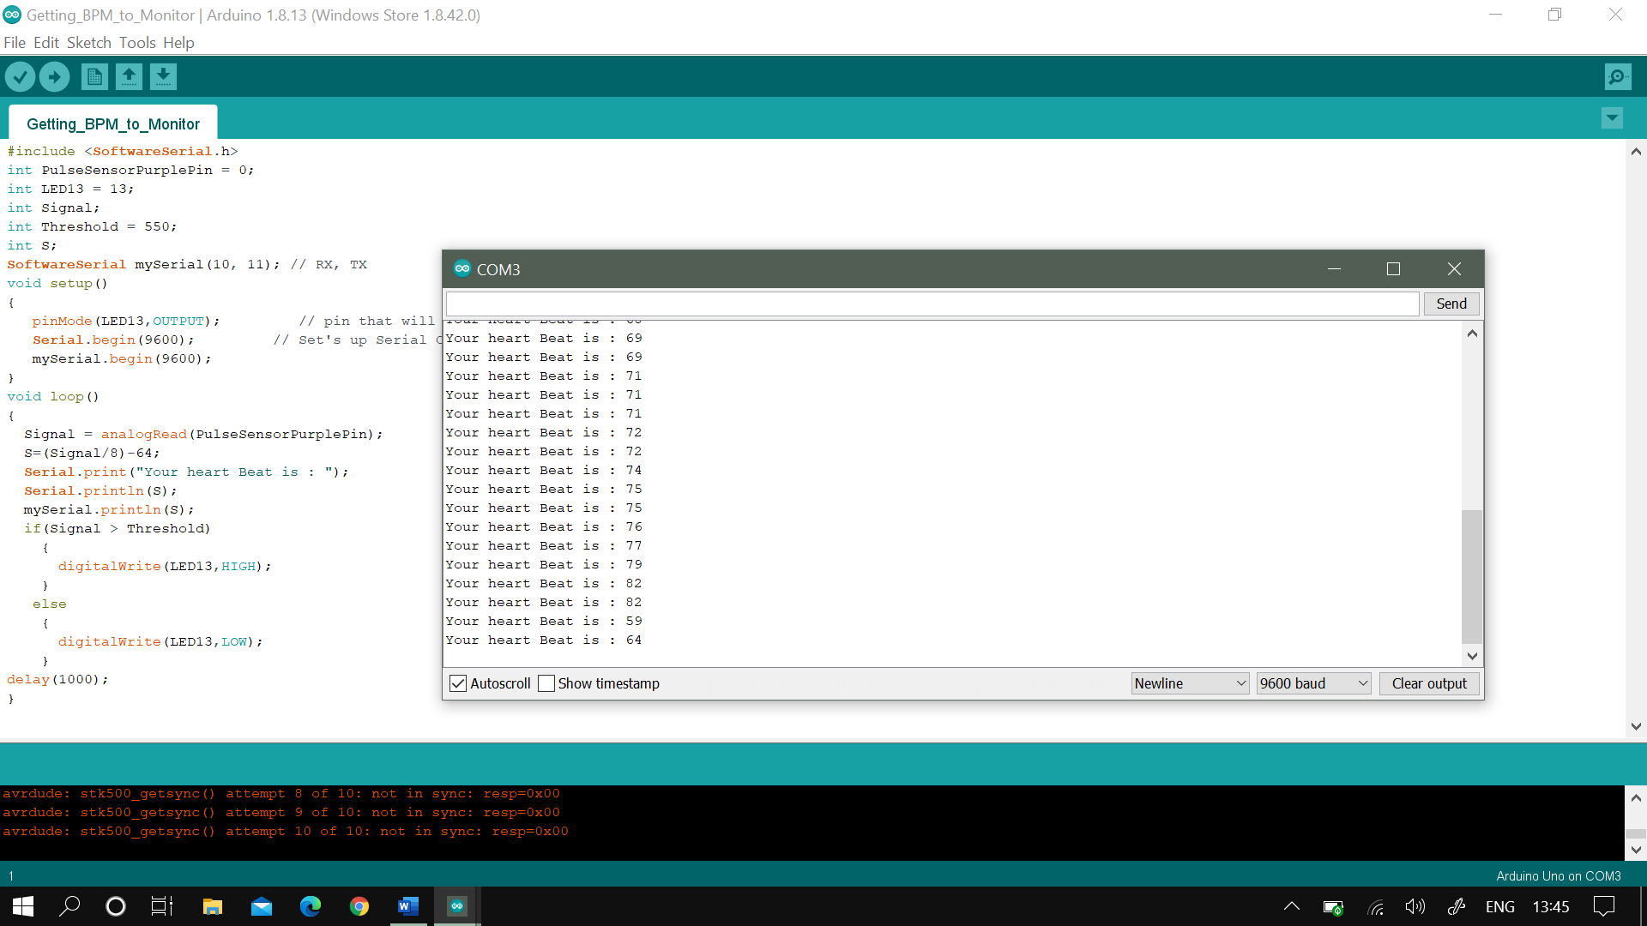
Fig.5.1 Heartbeat readings

- Execution in AWS:

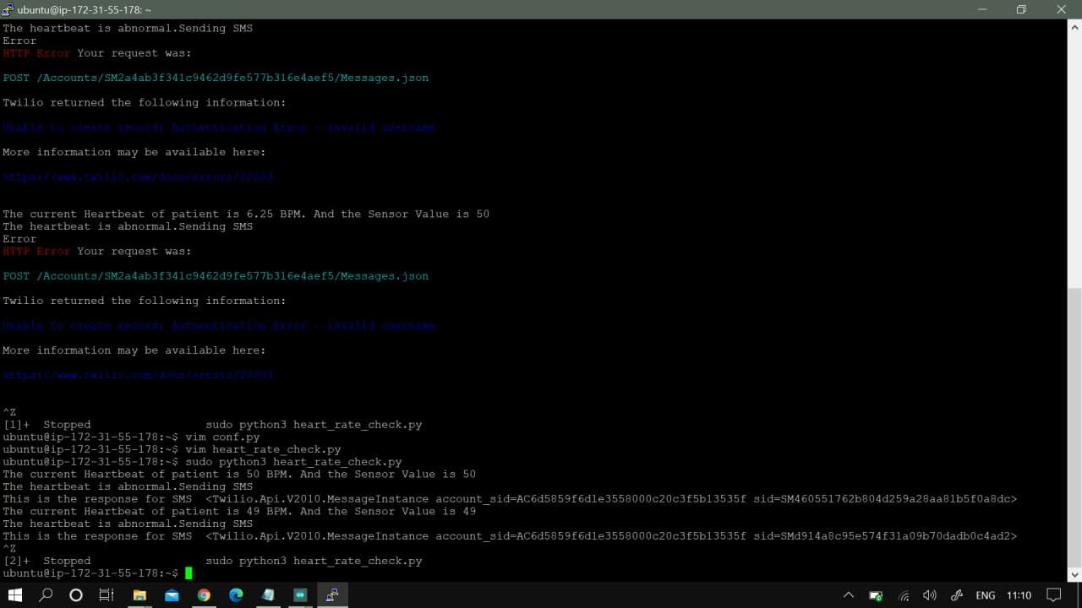

Fig.5.2 Execution in AWS console

- Execution in Twilio:

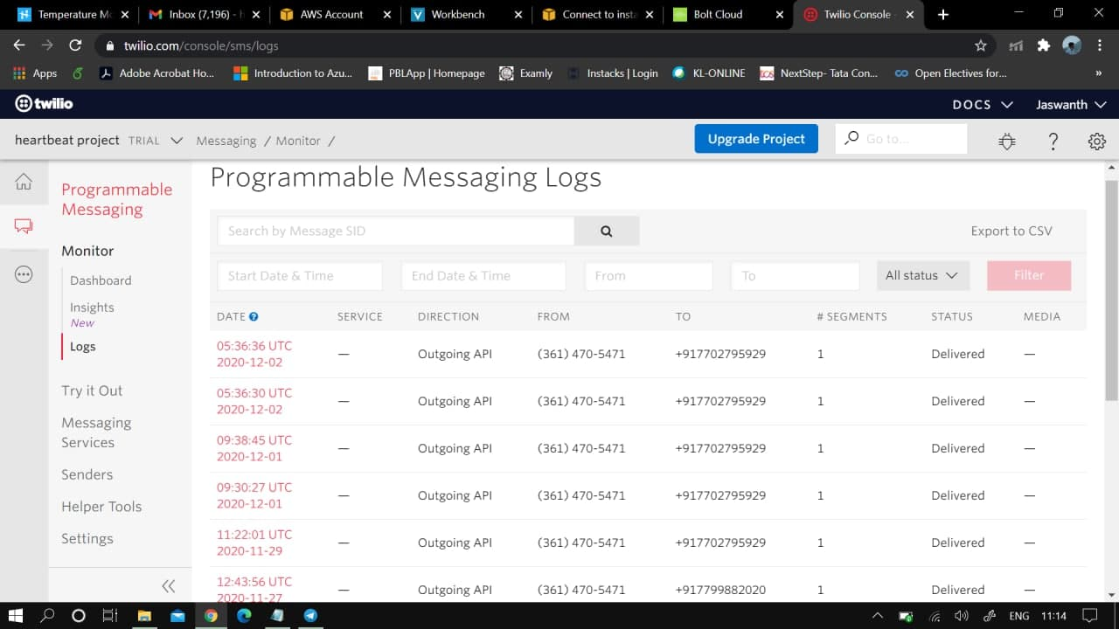

Fig.5.3 Twilio execution

- Client Output:

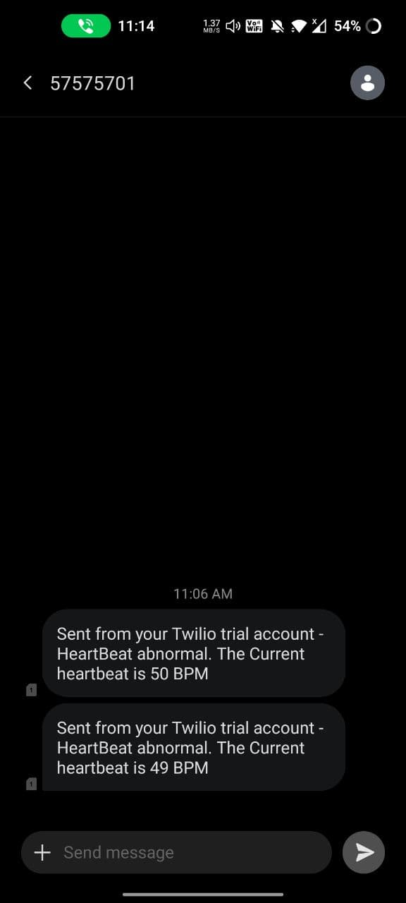

Fig.5.4 SMS received by client

As we can see here the values which are calculated by the
Sensor is sent to the AWS cloud where the data is monitored
With a threshold value and according to which an SMS is sent.

CONCLUSION

This covid-19 pandemic has caused many problems to everyone and especially the most affected ones are the patients. Patients whose heart pulse needs to be monitored regularly by the concerned doctors are affected by this Covid-19 outbreak. There has been a communication gap formed between these patients their concerned doctors/caretakers. Due to the implementation of lockdown all over the world, the situation got worse for the patients. This is where our idea flourished to help those section of patients whose heart pulse needs to be monitored regularly. With the help of the knowledge we gained from the concepts of IOT and its applications in medical field, we have researched and studied many research papers related to our problem statement. After reviewing many papers, finally we have chosen one paper as our base paper and started working on the idea. Our project “Heart Pulse Detection and Notification System using Arduino” mainly focuses on the communication gap between the patients and their doctors. The main aim of our project is to establish a communication bridge between the patients and the concerned well takers/doctors. We have used reliable components such as Arduino uno, which is the brains of our system, KY039 heart pulse sensor, which detects the heart pulse of the body, and BOLT Wi-Fi module for establishing a connection to send data through the internet. We have used the most reliable VPS service provider which is the AWS VPS to run the program(code) required to detect the abnormality present in the heart pulse. For the notification module, we have used TWILIO as our online API service which sends data to the concerned doctor whenever there is an abnormality present in the patient’s heart pulse.

References

- Remote Patients Monitoring System(Heartbeat and Temperature) using Arduino,Ruaa Shallal Abbas Anooz, Methodology -using IOT,IJSER,Volume 9,ISSN 2229-5518, August 2018.

- Internet of Things for Smart HealthCare: Technologies, Challenges, and Opportunites, Stephanie B. Baker , Wei Xiang , Ian Atkinson,IEEE Access, Volume-5, doi; 10.1109/ACCESS.2017.2775180, November 2017.

- A study on cloud based Internet of Things: CloudIoT, Shaik Masthan Babu, A. Jaya Lakshmi , B. Thirumala, IEEE Access, DOI: 10.1109/GCCT.2015.7342624,December 2015.

- On the Integration of Cloud Computing and Internet of Things, Alessio Botta, Walter de Donato, Valerio Persico, AntonioPescape,IEEEAccess,DOI: 10.1109/FiCloud.2014.14, December 2014.

- Heartbeat Monitoring Using IoT, Sayan Banerjee, Souptik Paul, Rohan Sharma, Abhishek Brahma,IEEE Access, DOI: 10.1109/IEMCON.2018.8614921, January 2019.

- Analysis of Heart Rate and Body Temperature from the wireless monitoring system using Arduino,Mohammad Dabbagh. Methodology – using IOT,Journal of Physics: ConferenceSeries,doi:10.1088/1742-6596/1358/1/012041,Published –Nov2019.

- Continuous Heart Rate and Body Temperature Monitoring System using Arduino UNO And Android device- Asaduzzaman Miah, Hussain Kabir, Siddiqur R Tanveer ,M.A.H. Akhand. Methodology – using IOT,IEEE access, Published –January, 2016 .

- Developing IOT Based Smart Health Monitoring Systems: A Review, Ashikur Rahaman, Muhammad Sheikh Sadi, Sheikh Nooruddin.Methodology –using IOT,IIETA access,September 2019.

- Smart Healthcare Monitoring using IOT, ShubhamBanka, Isha Madan and S.S. Saranya. Methodology – using IOT,IJAER, ISSN 0973-4562,Volume 13, January 2017.

- Development of smart health care monitoring system in IoT environment, Md.Milon Islam, Ashikur rahaman, Md.rashedul Islam.Methodology– using IOT,Springer,Article-185(2020),May2020.

- Low cost Heart rate Portable Device for the Risk patients with IOT and warning system,Muhammad Irman, Era Madon. Methodology-using IOT, IEEE access, INSPEC Accession -18596175,doi: 10.1109/icaiti.2018.8686761,April 2019.

- An IoT-Based Smart Framework for Human Heartbeat Rate Monitoring and Control System,Sani abba, Abubakar Mohammed garba. Methodology -using IOT,Research Gate,proceedings 2019,doi:10.3390/ecsa-6-06543,November 2019.

- IoT Based Heart Activity Monitoring Using Inductive Sensors, Adrian Brezulianu,Oana Geman. Methodology-using IOT, Sensors,Volume 19,doi:10.3390/s19153284, july 2019.

- A smart system for remote monitoring of patients and SMS messaging upon critical Condition Angad Kale, Siddharth.K. Kaul, Debi Prasad Das and S. Raghunath. Methodology-using IOT,IEEE Access,doi: 10.1109/WCSN.2007.4475765,March 2008.

- Web-based remote monitoring of infant incubators in the ICU,D.I. Shina, S.J. Huha,T.S. Lee , I.Y. Kimc. Methodology-using IOT, IJMI Access,doi:10.1016/S1386-5056(03)00095-9,September-2003.

